emicalculator.net

FIND THE INTEREST AMOUNT FOR CURRENT YEAR

REQUIREMENTS

|  |  |  |  |
| --- | --- | --- | --- |
|  | Prepared By | Reviewed By | Approved By |
| Name | Binary Lords | Lakshmi Priya NJ |  |
| Role | Programmer Analyst Trainee | Batch Trainer |  |

# CONTENTS

1. INTRODUCTION…………………………………………………………3

1.1 INTENDED AUDIENCE

1.2 PROJECT SCOPE

2. OVERALL DESCRIPTION……………………………………………..3

2.1 OPERATING ENVIRONMENT

3. REQUIREMENTS……………………………………………………….4

3.1 FUNCTIONAL REQUIREMENTS

3.1.1 REQUIREMENT 1

3.1.2 REQUIREMENT 2

3.1.3 REQUIREMENT 3

3.1.4 REQUIREMENT 4

3.1.5 REQUIREMENT 5

# 1.0 INTRODUCTION

EMI Calculator for Home Loan, Car Loan & Personal Loan in India is a web application that is used to calculate EMI for home loan, car loan, personal loan, education loan or any other fully amortising loan.

We are testing functionality of the website (i.e.) finding the EMI for Car Loan with specific inputs and displaying the EMI amount, calculating Home Loan EMI and extracting all the results into excel sheet, and providing a UI check for all text boxes and scales under Loan Calculator option.

## 1.1 INTENDED AUDIENCE

* 1. Business Unit (BU) SME
  2. Academy Coach
  3. Technical Trainer

## 1.2 PROJECT SCOPE

This document defines at a functional level the business activities that are encompassed by the system and the rules that apply to them. It also encompasses some of the key high and low level technical requirements of the system.

It draws heavily on both proposed Framework and Business Rules and the Technical Architecture documents. The scope of the detailed analysis project phase specifies that this document will include,

1. Classification of requirements according to their functional areas.

2. A description of each process in the system, including their inputs, outputs, and data transformation rules.

# 2.0 OVERALL DESCRIPTION

2.1 OPERATING ENVIRONMENT

Windows Operating System

Mac OS

Web Application

# 3.0 REQUIREMENTS

This part of the requirements document serves to present, finding the EMI for Car Loan with specific inputs and displaying the EMI amount, calculating Home Loan EMI and extracting all the results into excel sheet, and providing a UI check for all text boxes and scales.

3.1 FUNCTIONAL REQUIREMENTS  
3.1.1 REQUIREMENT 1

1. User clicks on “Car Loan” tab.
2. User enters “Car Loan Amount” as 15,00,000 or set the slider to 15L.
3. User enters “Interest Rate” as 9.5 or set the slider to 9.5.
4. User enters “Loan Tenure” as 1 or set the slider to 1.

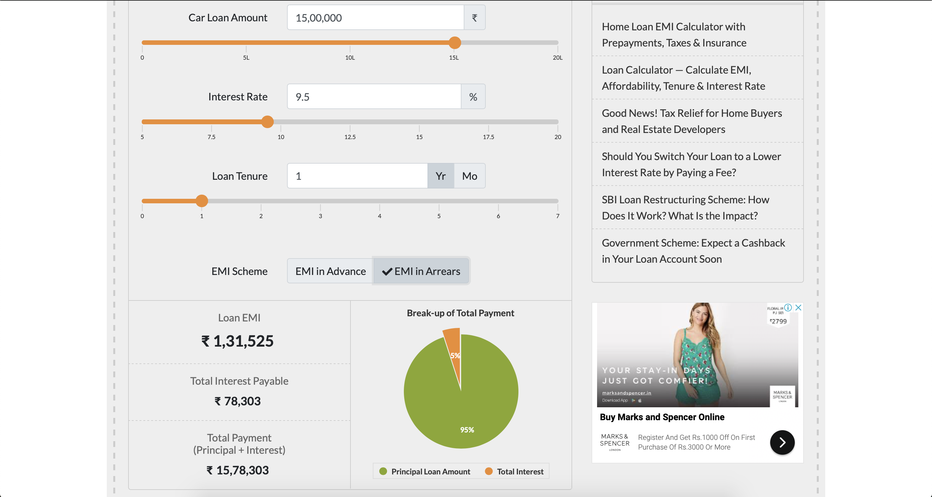

Figure 1 : Requirement 1

3.1.2 REQUIREMENT 2

1. User selects “Home Loan EMI Calculator” from the top menu.
2. User provides valid input data to all the fields
3. User scrolls down to the year on year table.

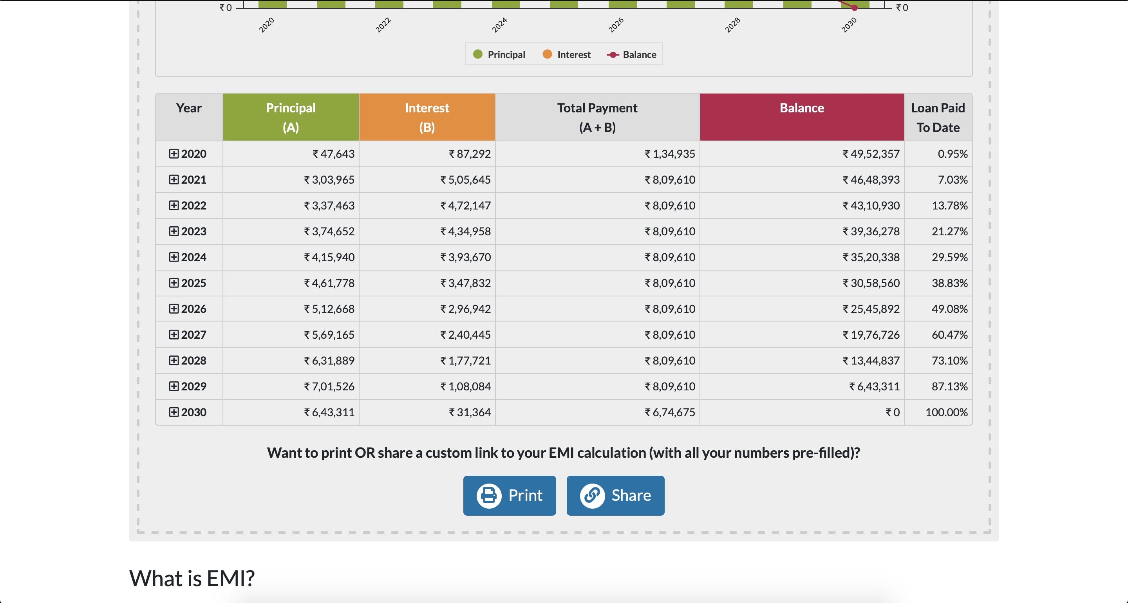

Figure 2 : requirement 2

3.1.3 REQUIREMENT 3

1. User clicks on “Calculators” from the top menu.
2. User clicks on “Loan Calculator” from the dropdown.
3. User selects “EMI Calculator” tab.
4. User provides valid inputs for all text boxes.
5. User changes the “Loan Tenure” value for year & month, to check the change in scales/slider.

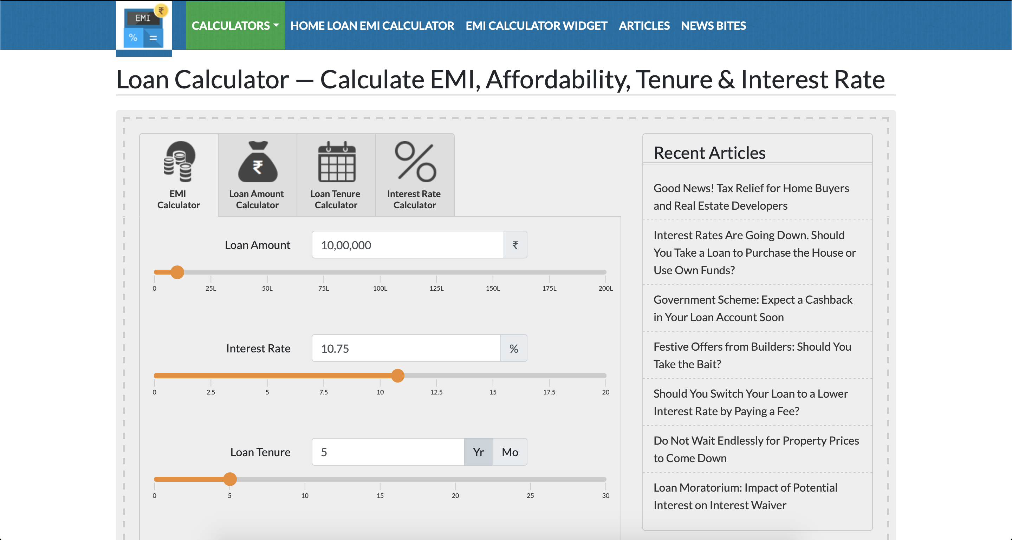

FIGURE 3 : REQUIREMENT 3

3.1.4 REQUIREMENT 4

1. User clicks on “Calculators” from the top menu.
2. User clicks on “Loan Calculator” from the dropdown.
3. User selects “Loan Amount Calculator” tab.
4. User provides valid inputs for all text boxes.
5. User changes the “Loan Tenure” value for year & month, to check the change in scales/slider.

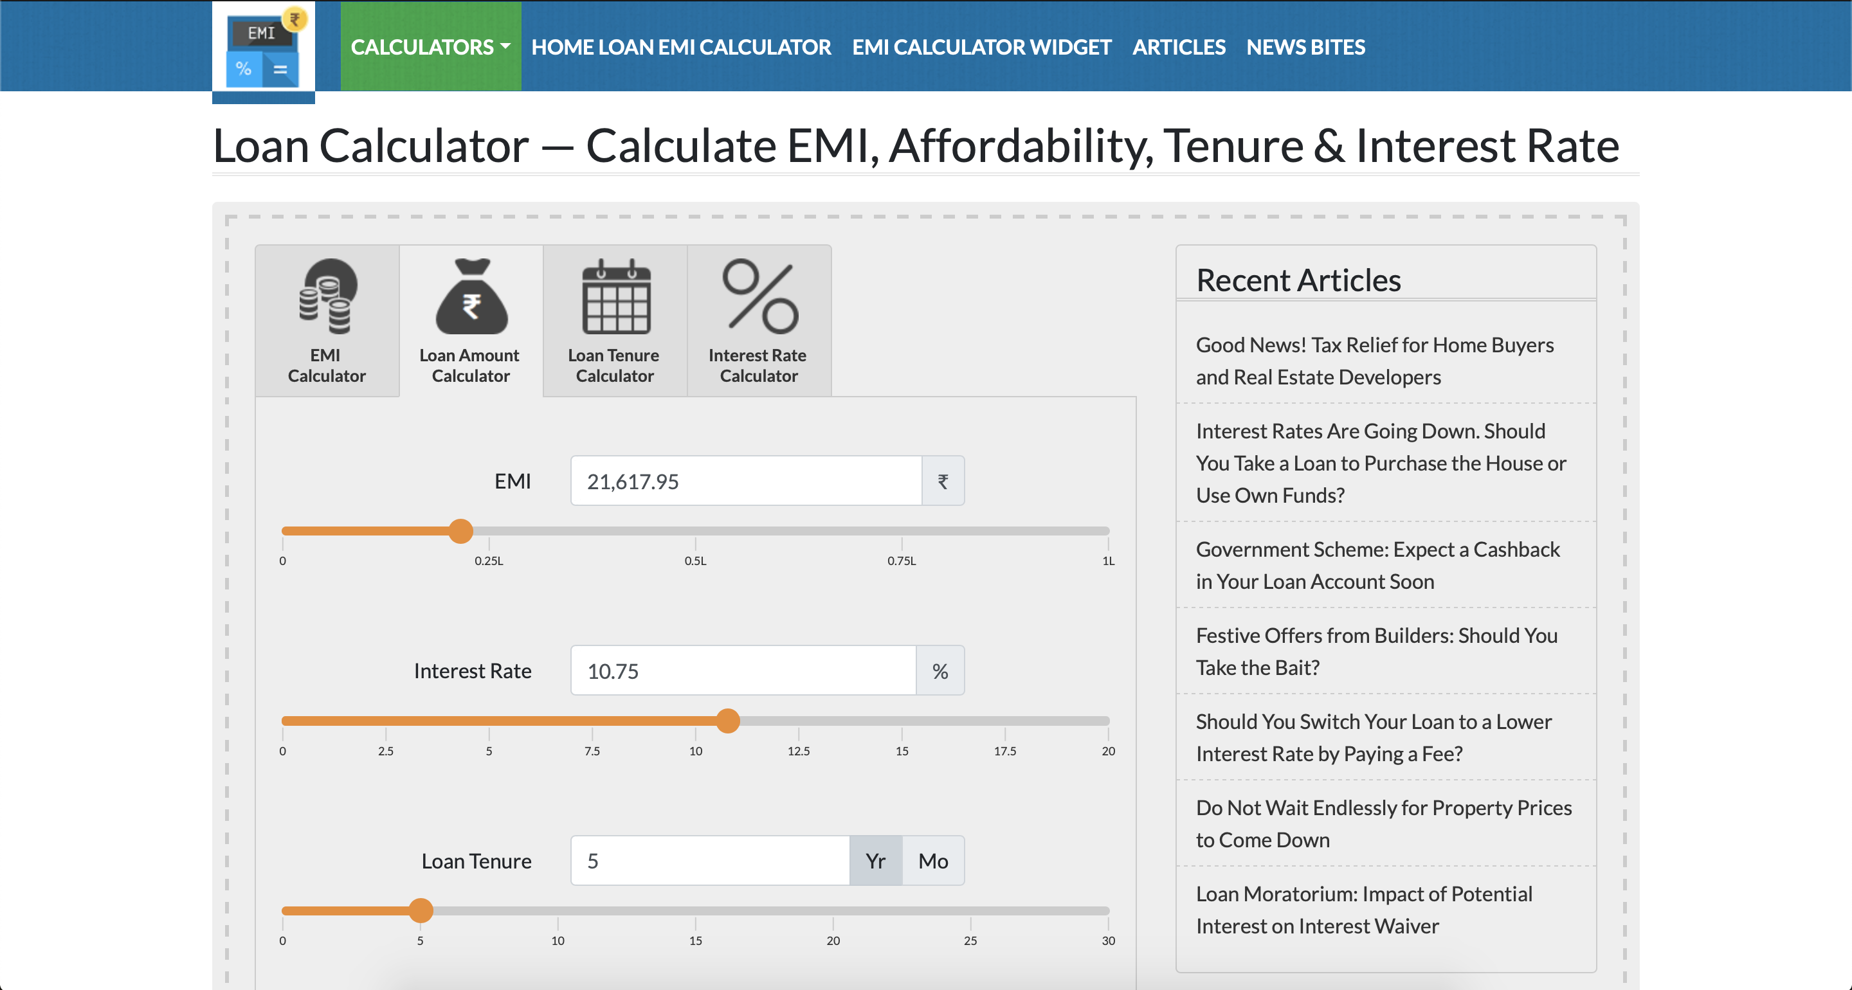

FIGURE 4 : REQUIREMENT 4

3.1.5 REQUIREMENT 5

1. User clicks on “Calculators” from the top menu.
2. User clicks on “Loan Calculator” from the dropdown.
3. User selects “Loan Tenure Calculator” tab.
4. User provides valid inputs for all text boxes.
5. User changes the “Interest Rate” value, to check the change in scales/slider.

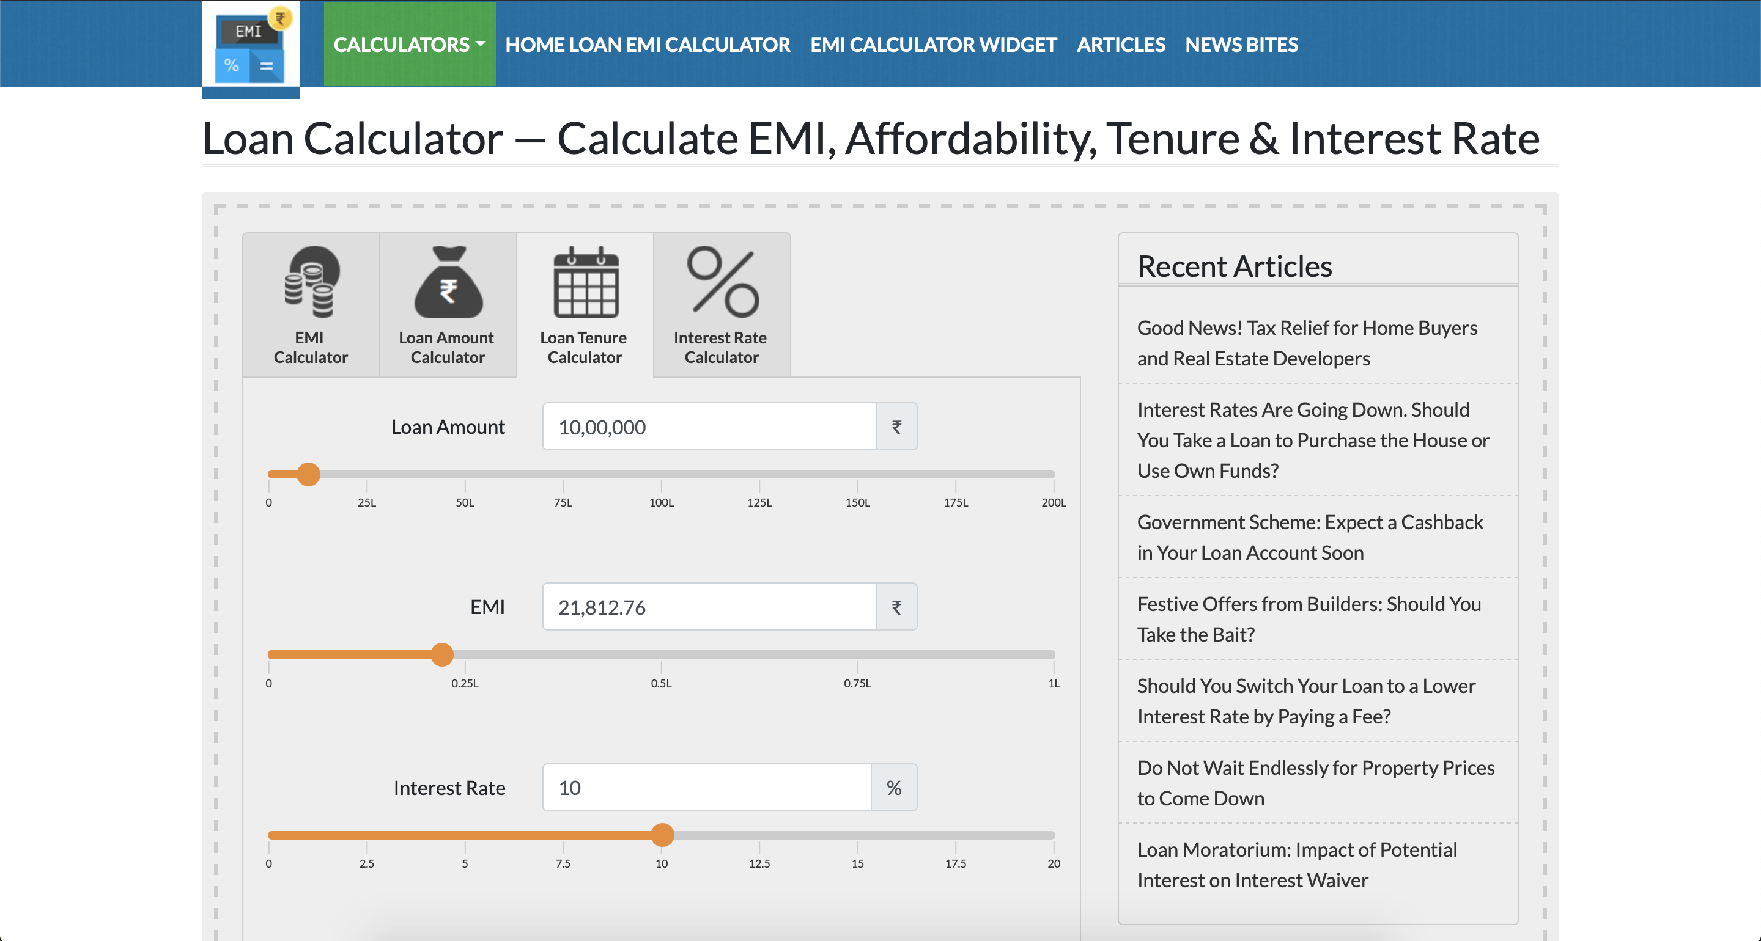

Figure 5 : requirement 5